This memo describes the method of beam steering and calculation of beam aim point for a TFD array. For details of the array construction, see the AJ4CO system diagram on the Radio Jove SUG web site.

Beam Aim Point Calculations

Calculation of the lengths of the time delay cables is tricky for the TFD array, but fairly straight forward. No heavy duty math involved. The calculations are described in the next section of this memo.

The question is: once you've installed some delay cables, where's the beam actually pointing?

This might seem to be reverse Polish logic, for wouldn't it be better to first determine where you wanted the beam to point and then install the proper delay cables to make that happen?

Well, no, it wouldn't be better. For arrays with relatively wide beam widths, it's much easier—not to mention way less expensive—to steer in increments E-W and N-S and just let the beam end up where it ends up.

So, for a rectangular phased array having axes aligned with the cardinal compass points, you beam-steer incrementally in the east-west and north-south directions to get Jupiter in the beam to the nearest increment. To do that, we need to know where each increment points the beam.

Obviously, finding out exactly where the beam is pointed is trivial if you only want to steer along one axis at a time.

But what happens if you steer, say, 45° south of zenith and 30° east of zenith, both at the same time? Where does the beam end up?

For small angles—say, less than 10° from zenith—plane trig provides an approximation that's close enough. Steer the beam 5° south and 5° east and your beam ends up with Az = 135 and El = 90 - (5 * sqrt(2)) = 83°. That's only 3 arcminutes from being correct.

However, as you get further away from zenith, the error in the planar approximation becomes unacceptable unto ludicrous.

Go 45° south and 45° east, and plane trig predicts a beam aim point 26° above the horizon to the southeast. The correct elevation should be 35°.

Go 70° and 70°, and plane trig predicts a beam aim point below the horizon.

The solution is simple enough: find the intersection of two great circles described by the two orthogonal steerings.

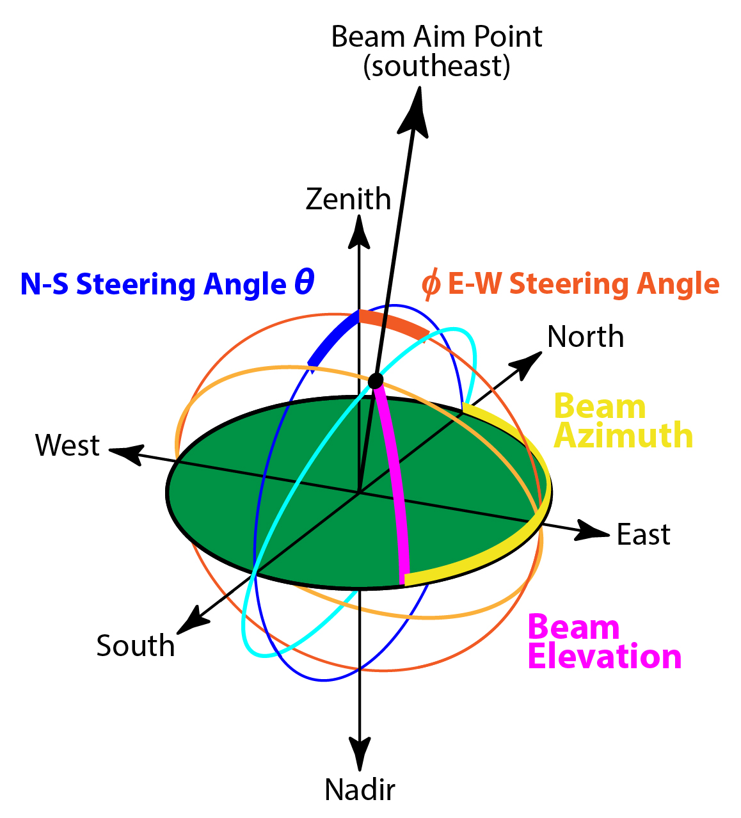

The east-west steering can be described by a rotation of the local meridian about the north-south line lying in the plane of the observer’s horizon (the 0°–180° azimuth line).

The north-south steering can be described by a rotation of the east-west meridian (or whatever it's called) rotated about the east-west line lying in the plane of the observer's horizon (the 90°–270° azimuth line).

Where these two great circles intersect above the array is where the beam is pointing.

Ah, but where, exactly, is that? How does one find the intersection points of two great circles or great arcs?

This turns out to be a surprisingly complex problem in spherical trigonometry.

Fortunately, we have trod nowhere new. Others have conquered this problem and left their solutions for all to see. One does not need to reinvent the wheel.

Here's the math, an algorithm, and a calculator.

http://geospatialmethods.org/spheres/GCIntersect.html

http://www.dirkbertels.net/computing/greatCircles_files/great_circles_070206.pdf

http://www.boeing-727.com/Data/fly odds/distance.html

http://articles.adsabs.harvard.edu/cgi-bin/nph-iarticle_query?1953Metic...1...39L&amp;data_type=PDF_HIGH&amp;whole_paper=YES&amp;type=PRINTER&amp;filetype=.pdf

Probably the simplest and most straight forward algorithm:

http://williams.best.vwh.net/intersect.htm

The math implemented in a handy web-based calculator:

http://homepages.ihug.co.nz/~gazzanic/greatcircle.html

Time Delay Cable Length Calculations

As described above, the TFD array is steered in increments. We chose 5° increments in the N-S direction and 15° increments in the E-W direction. This section explains why we chose those values and how they are achieved using delay cables.

For any array of linear elements from which circular polarization responses are synthesized, it is important to keep the signal levels between the two orthogonal sets of elements relatively close in power response—otherwise you don’t get a true picture of the circularly polarized emission you want to observe.

A square array—such as those in the TFD array—can be seen as two dual dipole Jove arrays orthogonal to each other. The dipole spacing in our case is 32 feet. At the emission source moves progressively east or west of the meridian, the Jove array with the north-south wires sees progressively less signal due to the difference in phase angle of the emission received by each wire. Far enough from the meridian, the two signals are 180° out of phase, producing a null in the beam pattern. The position of this null depends on the frequency of operation and the spacing between the dipoles.

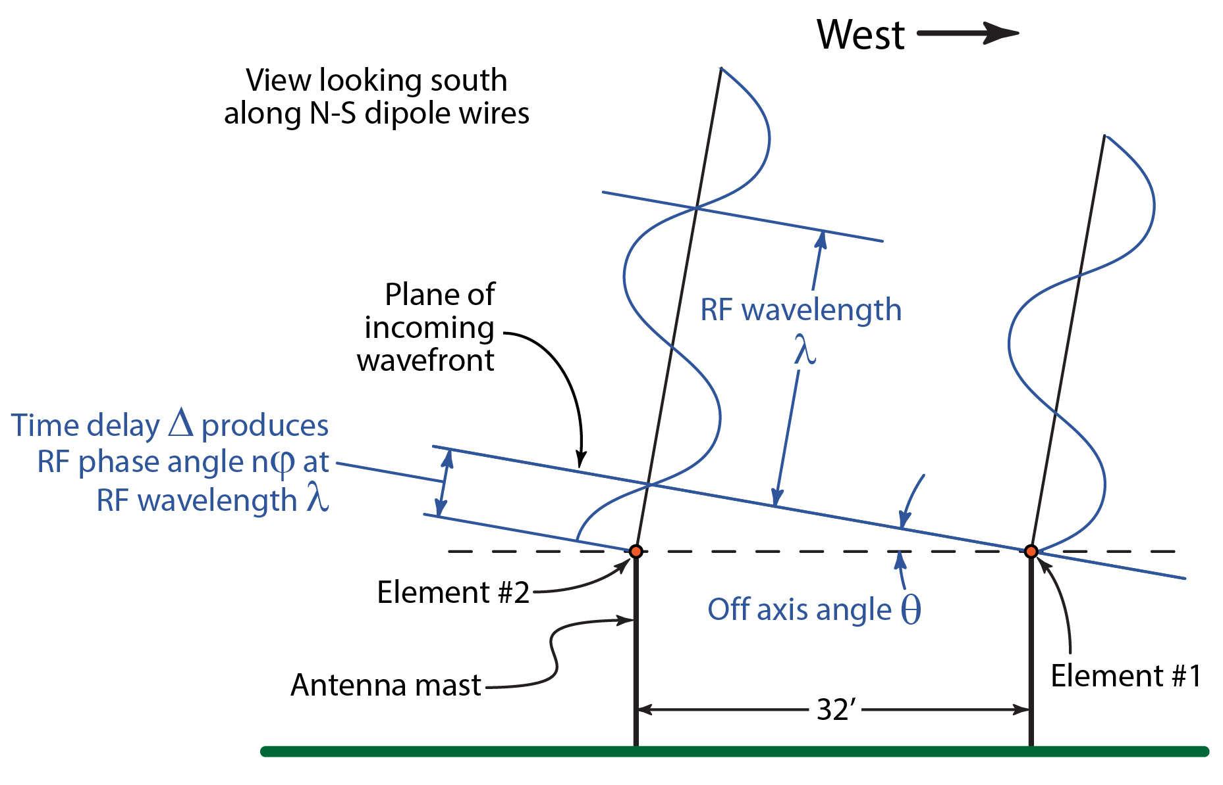

To generate the plot above, we start with the power from two voltage waves of the same frequency, but with different phase angles.

In the diagram above, the RF phase angle at element 1 is the reference point, so and

From the diagram, we can also see that

Thus, the equation used to create the plot above is

It can be seen from the 26 MHz trace that the attenuation is 3 dB when the emission source reaches 17° off axis in a direction normal to the element wires. 26 MHz is used as the benchmark frequency because most Jupiter emission occurs below this frequency. With this in mind, 15° is a reasonable figure for the beam steering increments in the E-W direction.

The 15° increment thus has less to do with HPBW (which is 17° x 2 = 34° at 26 MHz) and more to do with axial ratio. It should be noted that the 17° figure shown above only tells part of the story. From an axial ratio perspective, this figure is slightly smaller than it is in reality because a dual dipole array will also see some attenuation as the source moves off axis in a direction parallel to the wires. However, the attenuation in this direction is much lower. An EZNEC model of two TFD elements 32 feet apart shows that at 17° off axis in a direction parallel to the wires at 26 MHz, the gain is 1.2 dB down from maximum. So, to be safe, we use 15°, even though a more accurate 3 dB point (in axial ratio) is around 20°.

In the N-S direction, we chose a 5° increment due to the slow rate at which Jupiter changes in declination. This smaller increment requires many more sets of delay cables for the N-S steering, but the N-S steering is generally changed only between Jupiter observing seasons, roughly once per year. Using the 5° N-S steering increment allows the beam to more accurately track Jupiter’s path across the sky while not being overly burdensome to implement.

There is another important reason to use a smaller increment in the N-S steering: the TFD array consists of two square arrays along a N-S line. The center-to-center distance of the two squares is 64 feet. When power combining the signals from these two squares, the baseline is not 32 feet as in the previous examples, but double that—which in turn halves the suggested steering increment to 7½°. This, however, is larger than the 5° increment we use to best track Jupiter’s declination, so the N-S steering increment remains at 5°.

To understand how to implement the desired steering increments in delay cables, we must first review how an array of dipoles is beam-steered using time delay cables.

Confusion often exists between time delay cables and phasing cables. This is unfortunate, for all such cables are really time delay cables. It is true that they all provide a phase delay dependent on frequency—but stating the delay in terms of degrees of phase at one frequency is merely a different way—sometime a more convenient way—of stating the time delay being provided. However, when it comes to calculating beam steering for an array of wideband antennas—such as the TFD array—one must work in terms of time, not phase, for phase relationships change with frequency while time delays do not.

The purpose of a time delay cable is to alter the time at which a signal is combined with another signal.

In the diagram below, we imagine a plane wavefront inbound to the antenna array from a point 10° off axis to the south.

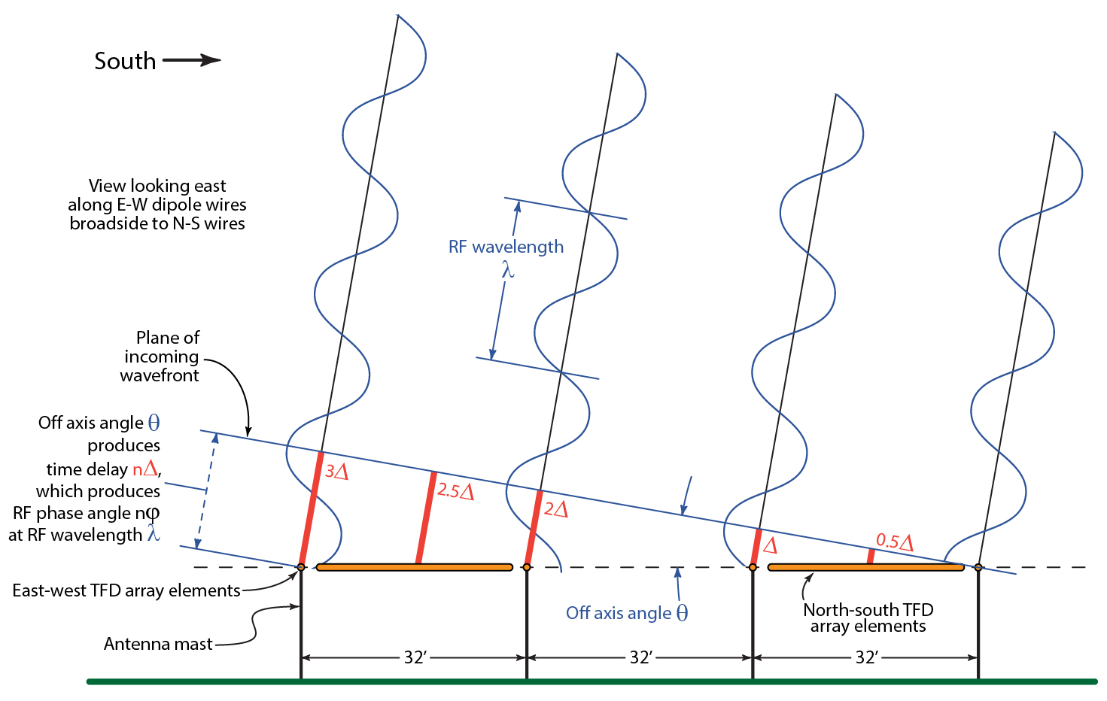

The circles in the RJP sky map are 20 degs.

The idea is to engineer a passel of coax relays into a remote beam steering system. I think Wes found enough relays. For now, though, I'll just schlep out to the array and swap out delay cables for every beam change.

...and then we can add progressive attenuation to the N-S or E-W wires to keep the X-Y axial ratio proper depending on steering angle and Jupiter's position...

