SuperJove Array Version 2 — Theoretical Beam Pattern
Dave Typinski
June, 2012

I desired to do a site survey of the UFRO facility in Dixie County, Florida. To that end, I will move the SuperJove array(The JOVE Bulletin, Nov 2011, http://radiojove.gsfc.nasa.gov/library/newsletters/toc.htm) from its current location in High Springs to around 75’ southwest of the UFRO observatory building. Using a multicoupler, this array will feed the UFRO spectrograph (FS-200B) and two Jove receivers.
Since the array is being moved, I decided to use the opportunity to eliminate the extra gap in the middle of the array, in so doing making all four elements evenly spaced at 20’ apart. This will necessitate changes to the delay cable lengths.

Delay Cable Calculations
A new delay cable analysis was performed assuming a design center frequency of 21.7 MHz, a location of 29.5°N latitude, and 20°N declination for Jupiter at transit (a good approximation through the end of 2014). The desired beam elevation can be found by first finding the elevation of the celestial equator, then adding the declination of Jupiter.
A diagram of the layout of the array helps envision how delay cables are used to steer the beam.
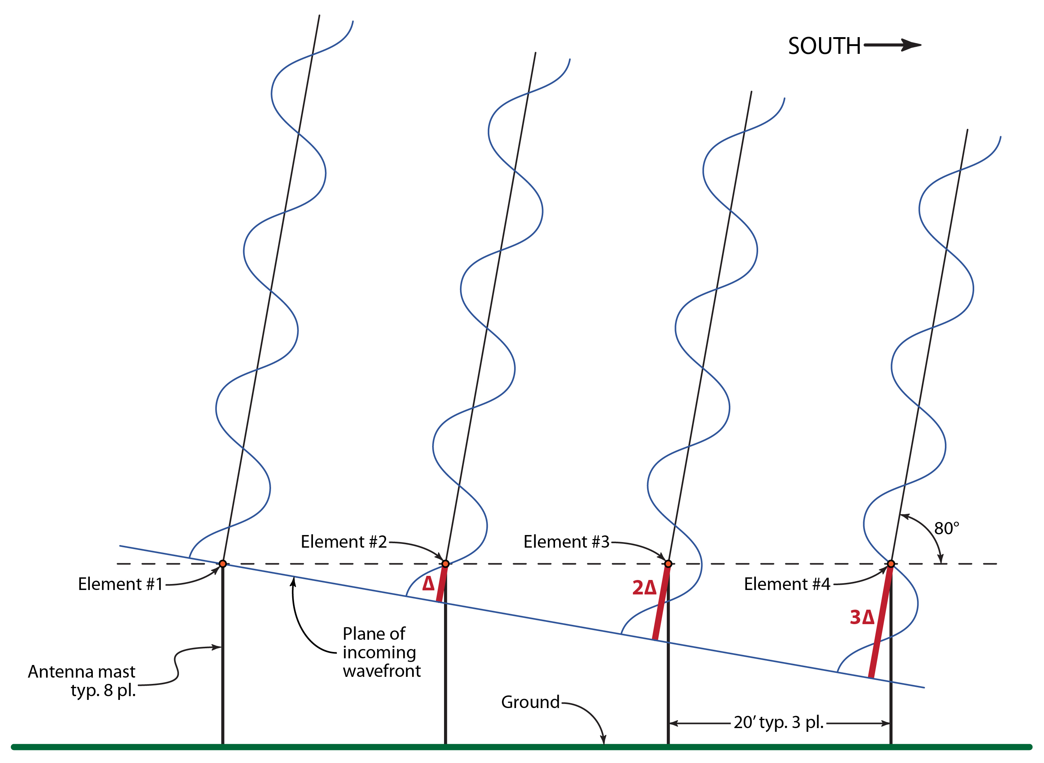
Figure 1 – SuperJove v2 array layout, looking East towards the ends of the element wires.

If we envision plane waves coming toward the array from 80° elevation to the south, it can be seen that the wave plane will strike the southern-most element first and the northern-most element last. If we send the signals from the elements to a power combiner without taking this fact into account, they will combine out of phase and thus the antenna’s response won’t be at its highest. That’s another way of saying that the antenna’s beam will not be pointed at 80° elevation, but somewhere else.
To aim the beam of the antenna array toward 80° elevation, we must add a delay into each of the three feed lines connected to the three southern elements. This can be done easily by adding an appropriate length of coax cable to each element’s feed line The northern element needs no delay because it is the last to receive a signal from 80° elevation. With the right amount of delay in each feed line, the signals are combined in phase, which is another way of saying that the beam is aimed south with an 80° elevation.
To calculate the proper delay for each array element, we must first calculate the extra distance the plane wave must travel to reach one element after the next.
The equation for each incremental increase (Δ) in travel distance is:

(1)

For the SuperJove v2 array, we have:

So, what we need is a way to add multiples of 3.47 feet of extra travel distance to the signals before they reach the power combiner. That is, the signals will be delayed by the extra length of travel distance. The figure calculated above, however, is the distance in free space. We must convert this to the distance needed when using coax. Since RF moves slower in coax than it does in free space, the length will be foreshortened by the degree to which the signal is slowed down. The equation for the equivalent incremental delay cable length in coaxial cable having a velocity of propagation (VoP) expressed as a fraction of c is:

(2)

Note that such delay cables are most often called time delay cables because they add extra travel time to the signal path. Extra time or extra distance, it all works out the same as long as you do the math right.
For the SuperJove v2 array, I am using Belden 8259 and LMR-400 coax. The VoP for any coax cable may be found on the manufacturer’s data sheet, or may be measured with an antenna analyzer or vector network analyzer. The incremental lengths of the delay cables for the SuperJove v2 array are found by:

While we don’t need to know the actual delay time, here is the equation for the incremental delay time, just for gee whiz purposes:

Which checks well against the 3.47 feet calculated above, remembering that in free space (not in coax cable), the speed of light is just shy of one foot per nanosecond.
It often makes the remainder of the array feed system design work go easier if we convert the incremental delay distance (in free space) into a phase in degrees at a certain frequency. The equation for the equivalent incremental phase delay at a given frequency f is:

(3)

For the incremental phase delay at 21.7 MHz, we have:

As long as it is remembered that the phase delay φ is in this case 28° only at 21.7 MHz, then we can use this phase delay to generate the required lengths of the time delay cables. This comes in very handy when calculating and verifying the physical layout and lengths of all the feed lines, for working with free space degrees is much easier than horsing around with feet and inches and VoP.

Calculation of Feed Line Lengths
Knowing the incremental time delay in terms of a phase at some frequency, we can plan the layout of the feed lines. Again, a diagram helps make everything a little clearer.

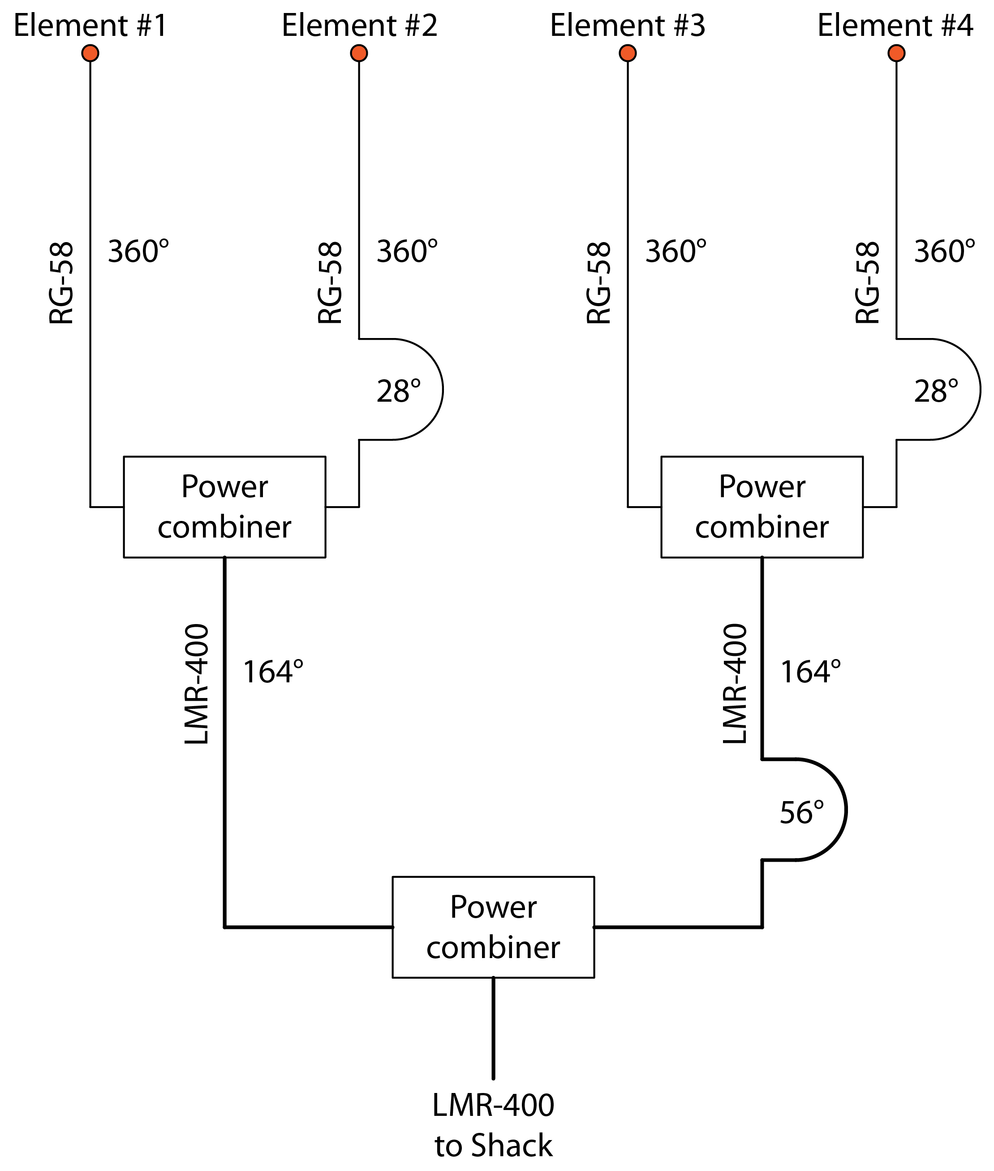
Figure 2 – Feed line layout of the SuperJove array, version 2.

Looking at Figures 1 and 2, we see that we must insert 3Δ of delay on the southern-most element (#4), 2Δ of delay on element #3, 1Δ of delay on element #2, and no delay at all on the northern-most element (#1). This arrangement of delays will allow the signals from 80° elevation to be combined in phase from each of the array’s elements.
One way to do this is with a 4-way combiner and four different feed line lengths, one for each element. The down side to that approach is that you end up with higher losses because the feed lines have to be long enough to actually reach the power combiner. Feed lines are usually lightweight—LMR-240 or RG-58, for example—and have higher losses than heavier, larger diameter coax—LMR-400 or RG-8, for example.
The way I chose to lay out the feed system is with three 2-way power combiners, keeping the small diameter (higher loss) coax short, and using low-loss coax to combine the two halves of the array, all while maintaining the proper delay relationships between the elements. It’s really not that difficult to do this.
We start by finding the minimum coax length needed for the northern-most element; this will be the shortest feed line of the four. I chose 1λ at 21.7 MHz, or 29’11” because it fits well with the physical dimensions of the array; you don’t want the feed line so short that you can’t move it around to cut the grass.
For this layout, we work one pair of elements at a time. Each of the southern elements (element #2 and element #4) will have 1Δ of delay added to its 29’11” feed line.
Then, we must combine the two array pairs. To find the delay needed for that, we simply note from Figure 1 that the southern pair of dipoles is 2Δ away from the northern pair (in terms of delay distance). So, the feed from the southern pair’s combiner to the final combiner needs to have 2Δ more signal path in free space (and consequently 2φ—or 56°—phase delay at 21.7 MHz) compared to the feed from the northern pair’s combiner.
However, I did not want to use a full 360° (1λ) of LMR-400. For one thing, it’s expensive, and for another, the VoP is high, and I didn’t want yards of the stuff laying all over the place unnecessarily.
To convert delay in degrees to length in coax at frequency f, we use:–

(4)

For the 56° in LMR-400, we have:

I looked at the distances on the ground that I needed to cover and decided I wanted a total of 44’ of cable between the two first stage power combiners. With that, we can calculate the lengths of the two LMR-400 feed lines via 2x + 6 = 44 ft  x = 19 ft, therefore the northern section of LMR-400 needs to be 19’ and the southern section needs to be 25’ long.
Then we just have to convert those back to phase delays so we can double check everything (see below). We use the inverse of equation 4:

(5)

For 19 feet in LMR-400 at 21.7 MHz, we have
Similarly, we find that 25’ in LMR-400 at 21.7 MHz is equal to 233°, which is 56° longer than the 19’ cable, just as it should be.
The last—and most important—step is to verify all this good-sounding mathematical trickery. This is done by making a table, one column for each element, and adding up all the phase delays between each element and the final power combiner. Trace the signal path from each element to the final power combiner, noting the length of the signal path in degrees along the way. Then normalize all the path lengths to element #1 to find the delays relative to element #1. If the feed system was planned properly, all the delays should be multiples of φ in an arrangement that agrees with Figure 1. Once this is verified, then the phasing delays can be converted to lengths in the appropriate type of coax cable using Equation 4 (see Table 2).

 | Element 1 |  | Element 2 |  | Element 3 |  | Element 4
Desired φ | 0° |  | 28° |  | 56° |  | 84°
RG-58 | 360° |  | 360° |  | 360° |  | 360°
RG-58 Delay |  |  | 28° |  |  |  | 28°
LMR-400 | 177° |  | 177° |  | 177° |  | 177°
LMR-400 Delay |  |  |  |  | 56° |  | 56°
Total Line Length | 537° |  | 565° |  | 593° |  | 621°
Normalize to Element #1 | – 537° |  | – 537° |  | – 537° |  | – 537°
Delay Relative to Element #1 | 0° | ✓ | 28° | ✓ | 56° | ✓ | 84° | ✓

Table 1 – Design verification of the feed system using phase delays.

RG-58 |  |  |  | LMR-400
360° | = | 29'11" |  | 177° | = | 19'0"
28° | = | 2'4" |  | 233° | = | 25'0"

Table 2 – Phase delays converted to the required delay cable lengths.

Results Using EZNEC+
The SuperJove v2 array and the feed line lengths were programmed into EZNEC+ to generate elevation and azimuth beam plots. An SWR sweep was not performed in EZNEC since I do not know how to model the power combiners in EZNEC—and I remain unsure if it’s even possible. The elevation plots were made in 1 MHz steps from 18 to 24 MHz. Azimuth plots were then made at the same frequencies, with the elevation parameter adjusted to the maximum gain elevation at each frequency.

