The SuperJove Double Dual Dipole (SJD3) Array
Dave Typinski, AJ4CO Observatory
September, 2011

In the never ending quest for reduced interference and better reception of Jovian emissions, I have installed a four-dipole array. The SuperJove Double Dual Dipole (SJD3 for short) array is simply two standard Jove arrays connected together.

The dipole wires run east to west. Each Jove array is separated by 40 feet in the north-south direction. Given Jupiter’s high elevation, almost 80° at transit for my latitude of 30° N, I phased the array for a beam centerline elevation of 78° according to the EZNEC model.

According to the model, the directivity gain is 11 dBi and the primary beam is a thin, fan-shaped affair running east to west. This is ideal for Jupiter observation. I can say without hesitation that the antenna has allowed me to observe a greater number of weak non-Io events, and greater detail (modulation lanes) in the stronger events, than I was able to see with my standard Jove array.

Here is a photo essay of the development and construction.

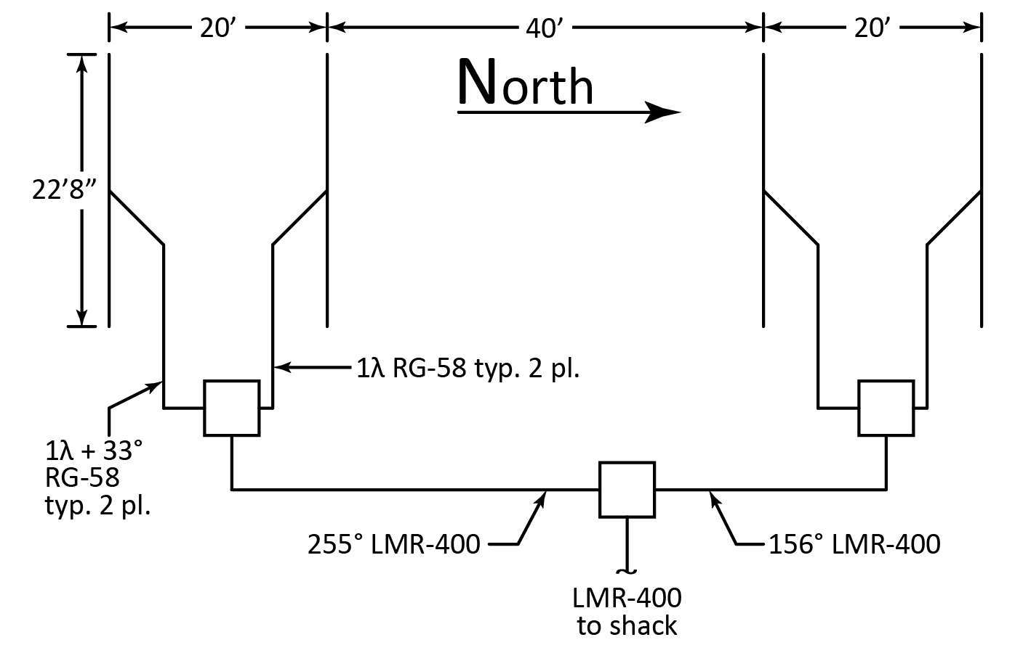

The two Jove arrays inside the SJD3 use 33° phasing on each of their southern elements. The southern Jove array is phased 99° to the northern Jove array.

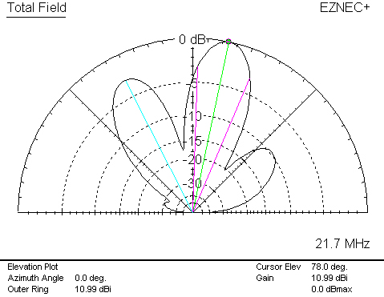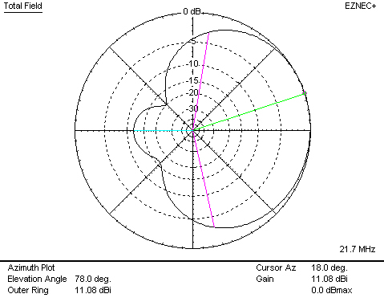

EZNEC theoretical azimuth and elevation plots. Notice the slight azimuth asymmetry due to the presence of the original Jove array to the west.

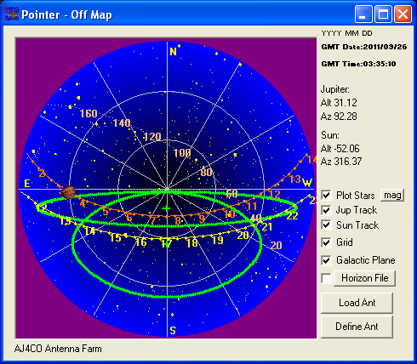
SJD3 array (skinny) and Jove array (fatter) half power beam width plots in Radio-Jupiter Pro.

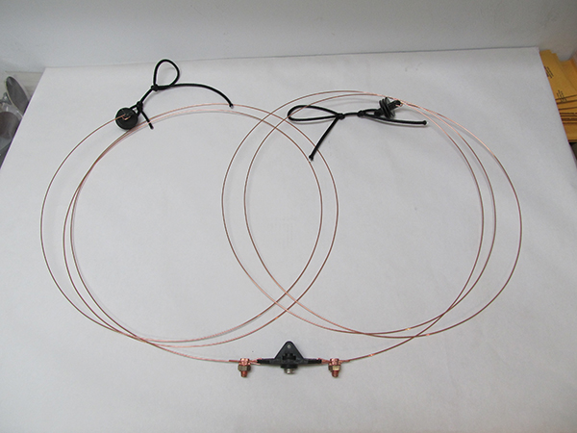
One of the four elements after pre-assembly. Overall length of wire, including the center insulator, is 22’8”. Wire is #14 Copperweld, attached to the Budwig center insulator with two split nuts. Small lengths of rope tied to end insulators make assembly in the field easy. Best part? No soldering, for easy disassembly later.

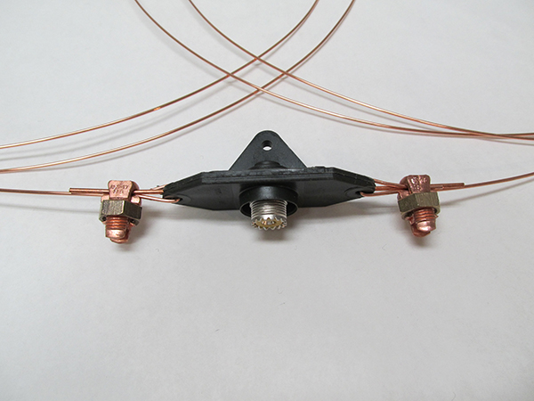
Detail of the center insulator.

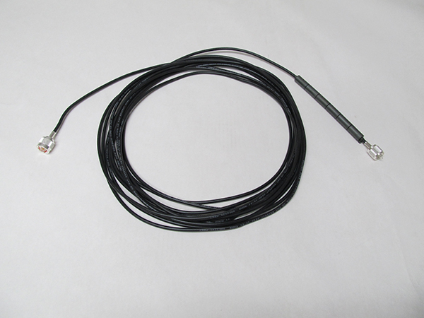
One piece of RG-58 (Belden 8259) cut to one wavelength long. The feed point end has a PL-259 crimp connector after six ferrite beads that form a common mode choke to act as a balun. These inexpensive toroids, Fair-Rite P/N 2631480002 available from Mouser, fit snugly on the RG-58. The far end has an N-male crimp connector for the power combiner.

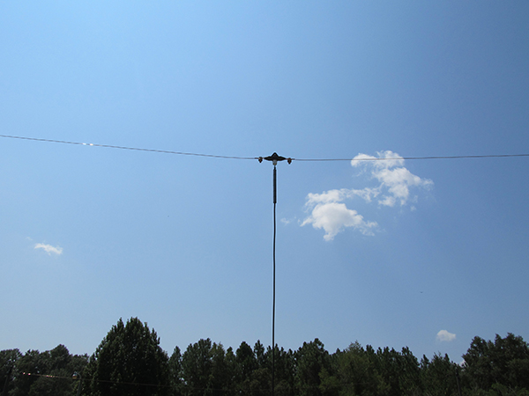
Feed point after element installation.

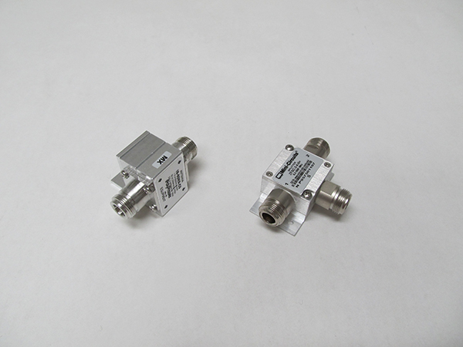
PolyPhaser IS-50NX-CO surge arrestor and MiniCircuits ZFSC-2-4-N+ power combiner (three combiners are used in the array). The surge arrestor is electrically bonded to the steel frame of the building where the feed line enters, which is in turn tied to a ground rod about 10’ away. The power combiners are not grounded in my installation.

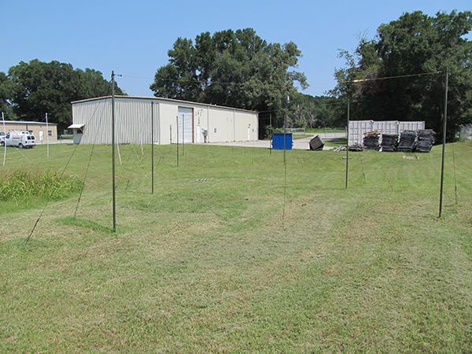
The completed installation, looking north. Elements are supported by military surplus green fiberglass tent poles, three poles per mast, placing the elements 10’ above the ground. Guy lines are military surplus 3/16” black polyester rope. With these materials, the array is quite stealthy and visually unobtrusive. All fixed ropes are tied with bowline knots; the adjustable guy lines are tied with trucker’s hitches.

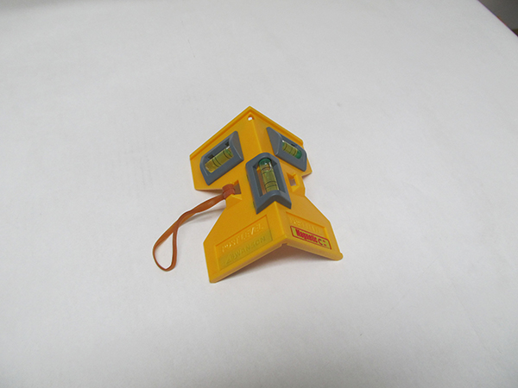
This wee four-dollar post level makes adjusting the guy lines a snap.

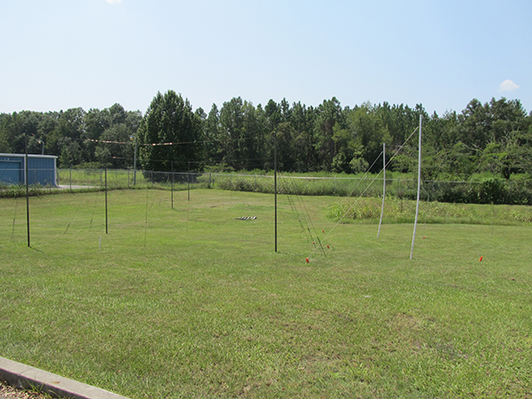
Looking south. SJD3 on left (dark green masts), original Jove array on right (white PVC masts).

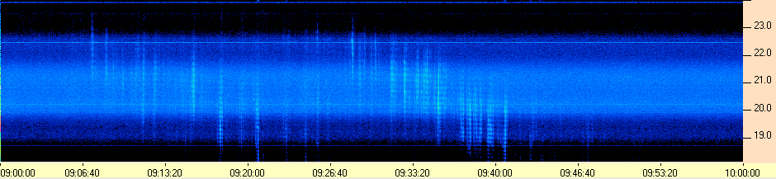
Weak non-Io-C seen with the SuperJove array on 9/16/2011.

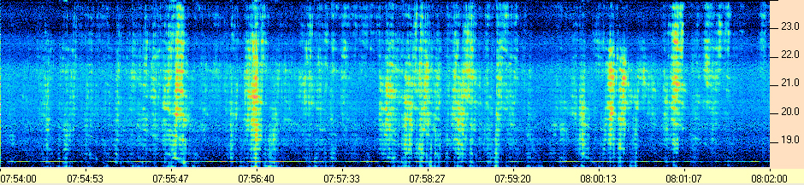
Io-B emission modulation lanes seen with the SuperJove array on 9/15/2011.

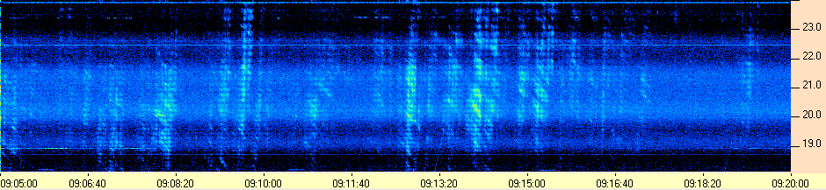
Io-B emission modulation lanes seen with the SuperJove array on 9/22/2011.

I had originally designed the SuperJove array in EZNEC using some phasing cable lengths that I selected through trial and error to produce a good beam pattern. However, I have since learned the time-delay method—i.e., the right way—of phasing dipoles together. In the future, the elements will be evenly spaced instead of having an odd gap in the middle. There are also tricks to lower the side lobes that I wish to try. That will be covered in Part 2 of the SuperJove array.

