4-Port Multicoupler and Bandpass Filter

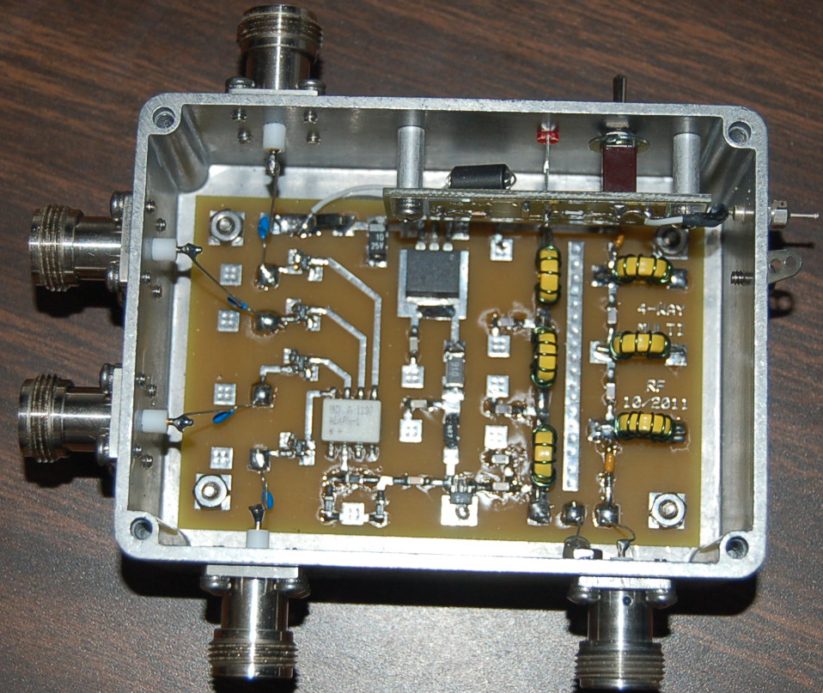

RF Associates
November 2011

The RF Associates 4-port multicoupler (MC) provides high isolation between output ports (in excess of 50 dB). Overall gain measured from the RF IN port to any of the four output ports is approximately 3 dB.

The MC uses a low noise GALI-74 MMIC followed by a four port power divider. The input to the GALI-74 is bandpass filtered (15 to 40+ MHz) to minimize overload and out-of-band interference. Both input and outputs are capacitively coupled.

Power required is a well filtered DC voltage between 15 and 18 VDC at 100 ma. The unit contains a 12 volt regulator and a polarity protection diode. Absolute minimum power supply voltage is 14.5 volts measured at the input to the MC. It is the responsibility of the user to provide power supply fusing if desired.

The MC block diagram as well as response curves follow.

4-way power divider MCL AD4PS-1+
1-500 MHz, 30 dB isolation

10dB Atten
MCL LAT-10+
10dB Atten
MCL LAT-10+
10dB Atten
MCL LAT-10+
10dB Atten
MCL LAT-10+
Attenuator
Unit Gain Setting
40 MHz Low Pass Filter
7th Order Cheby

Gali – 74+ Amp
25 dB Gain
2.7 dB NF,
IP3= +38dBm
19.2 dBm pwr out
15 MHz High Pass Filter
7th Order Cheby

12 VDC Regulator
LM1085IS-12
Power Switch,
RFI Filter Board
+15 to 18 VDC
100 ma
RF IN
RF Out
RF Out
RF Out
RF Out

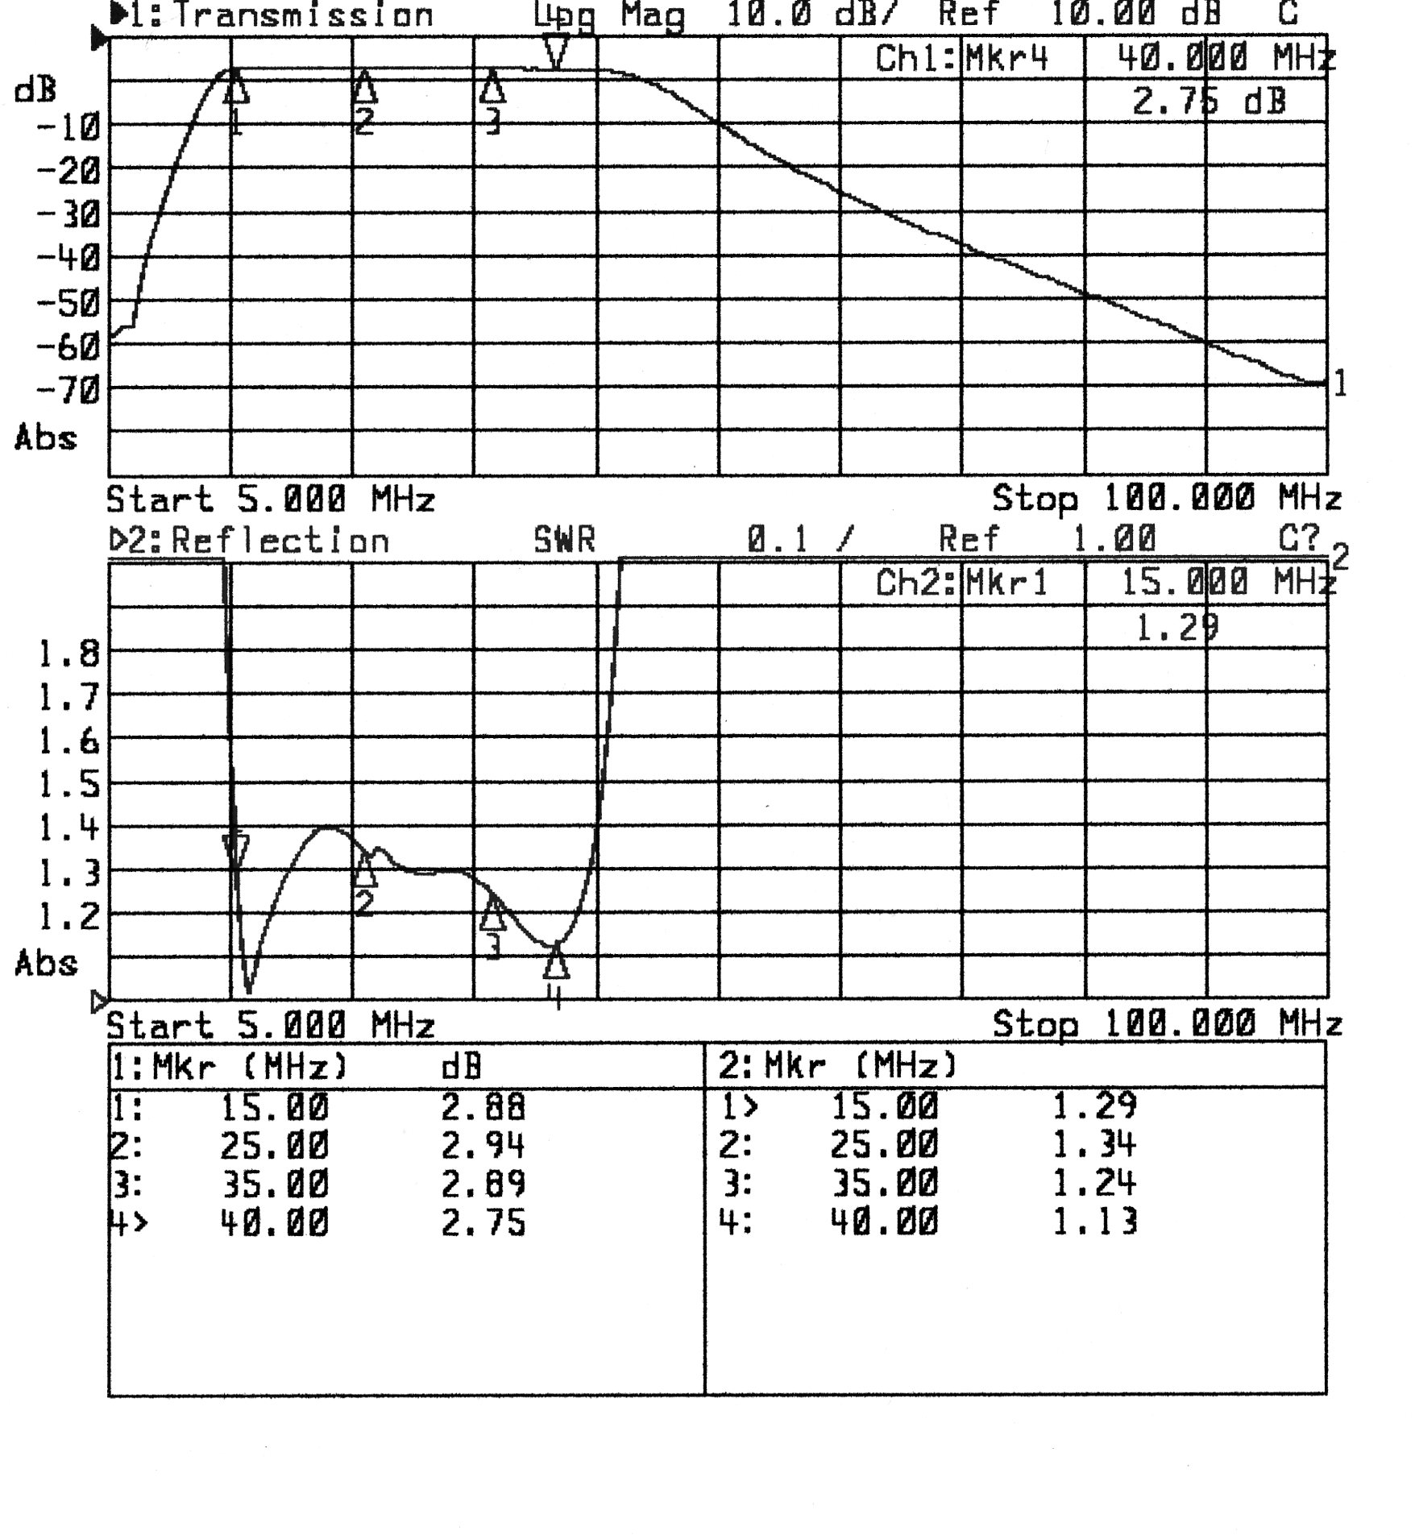
Multicoupler gain and input SWR (gain measured from RF IN to any of the RF OUT ports).

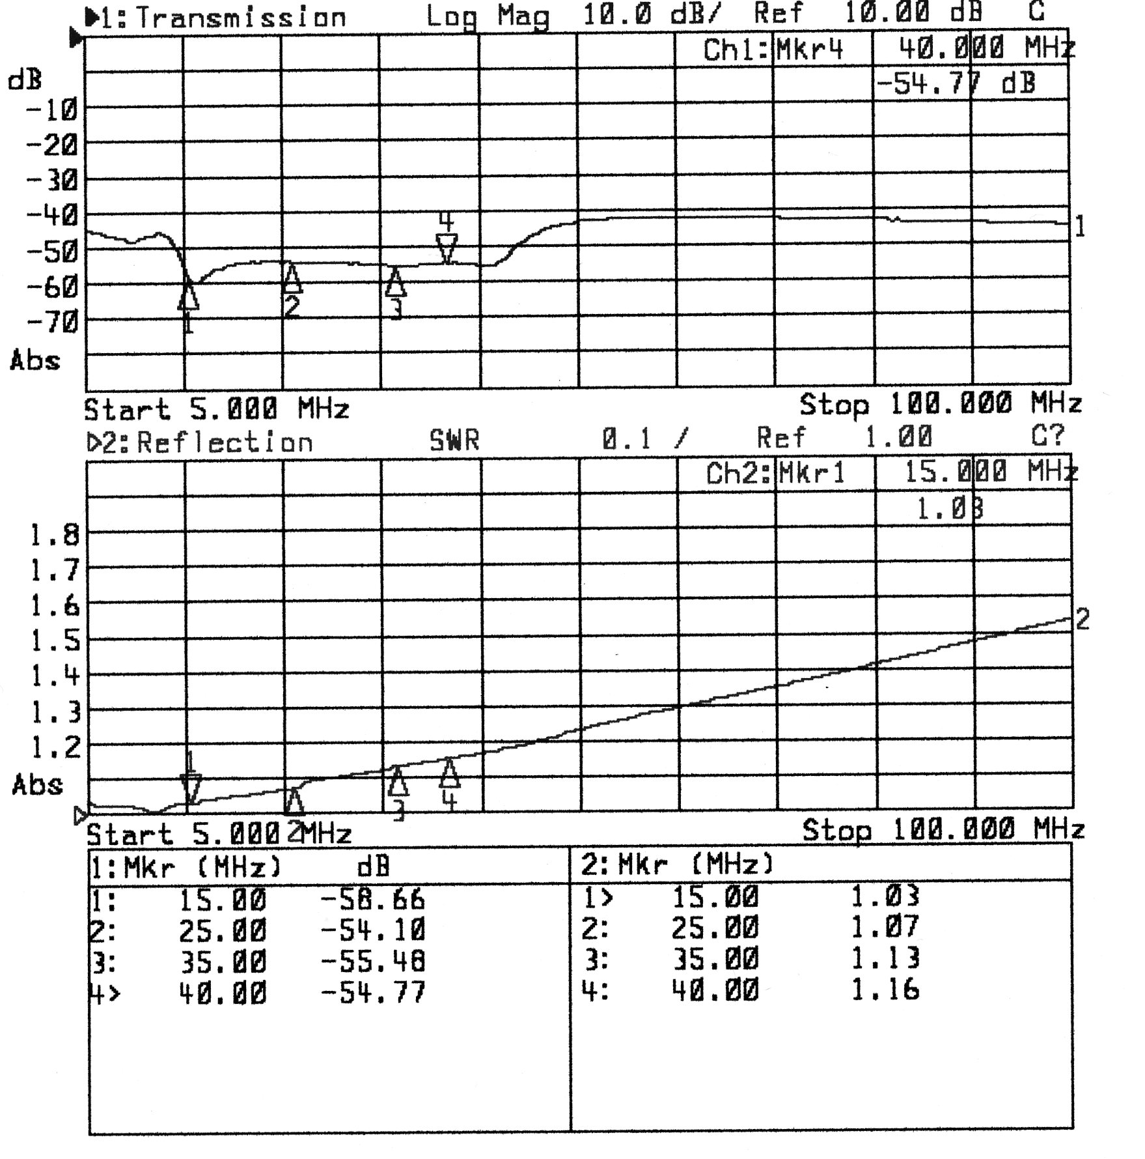

Multicoupler isolation and SWR (measured from RF OUT port 1 to RF OUT port 4 with power ON and RF IN terminated in 50 ohms.

