**Setting up the R-75 for best dynamic range.**

**What is dynamic range and why do we care?**

**The radio noise bursts we are studying can be very strong – raising more than 25 or 30 dB above the galactic background. We want to be sure that the radio is capable of following these large increases in signal strength without going into compression or saturation. In other words, if the input power to the receiver doubles we want to be sure that the output audio power also doubles. In the plot below we see both the linear and non-linear regions with the receiver going into compression as the input signal in this example exceeds (15) arbitrary units.**

**The dynamic range we are interested in is the range from the galactic background level (around 25,000 kelvin) to the peak signal temperature we can observe (around 30 million Kelvin). This is a dynamic range of about 30 dB.**

**This is the dynamic range suitable for very strong solar bursts and also for Jovian S-bursts which can have very high instantaneous peak values.**

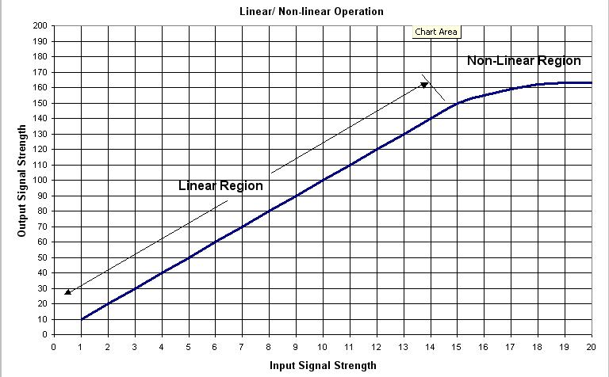

**What is Needed?**

1. **Icom R-75**
2. **HP-461 noise source of known temperature and manual step attenuator**
3. **Calibration Sheet (dB attenuation vs noise temp)**
4. **Radio SkyPipe**

**The calibration will be done with the attenuated noise source connected either to the R-75 antenna terminal or to the input of the multicoupler if one is used.**

**ICOM CALIBRATION PROCEDURE**

The first thing to do is set up the R-75 controls as follows:

**Mode – USB**

**Frequency - 20.030 MHz or other as desired.**

**Noise Blanker – OFF**

**Noise Reduction – OFF**

**Attenuator – OFF**

**Auto Notch Filter – ANF OFF**

**Preamp – 2 ON**

**AGC – AGC OFF**

**Audio from R-75 to computer from Recorder Jack on the rear panel of the R-75**

**Twin Passband Tuning** - **Both controls centered**

**Filter Setup- 9 MHz filter set to 6 kHz, 455 kHz filter set to 6 kHz**

Hold down the FIL button for 2 seconds to enter setup. Hit the DN button 3 times to the EXP filter. Default is Off. Turn on EXP by rotating the frequency knob CW until you see EXP ON. Punch DN to 455K (W). Rotate frequency knob to select 6 kHz. Punch the FIL button and you are done.

**Note:** This Filter Setup improves the **low-frequency** audio response and will increase the audio output by about 5 dB over the standard 2.4 kHz USB settings.

**RF Gain Control** – Initial Setting to 12 o’clock.

In order to find the best RF gain setting, set the attenuated noise source to 30dB of attenuation and establish a baseline on SkyPipe. It is not necessary to be properly calibrated at this point. In fact you will have to run the RSP Cal Wizard at the end of the RF Gain Control setting procedure.

Slowly rotate the RF control CCW. The output level will fall slowly. As you approach the 10 o’clock position (at least on Wes’s receiver) the gain will drop rapidly. Leave the control at the point just before the gain begins to drop rapidly.

You can now get a quick idea as to your dynamic range by decreasing the step attenuator in 10 dB steps and observing if the RSP temperature goes up by a factor of 10 each time. (You can do 3 dB steps and see if the RSP temperature doubles with each step.)

If you are not linear near the top (minimum attenuation), adjust the RF gain a tweak more CCW, and try again.

OK – now that you have all the controls set properly you need to run the cal wizard.

You must first run the Radio SkyPipe (RSP) Cal Wizard using zero (0) dB for the antenna coax loss. This will enable you to read directly from your RSP chart the step temperatures in degrees Kelvin. You may use any known noise source for the Cal Wizard run – either an RF2080 (25,000 k), or the HP461 with whatever attenuation is necessary to produce an output temp near 25,000 k. Enter the temperature at the Cal Wizard prompt.

Once the Cal Wizard run is complete it is time to take data to plot your response curve. This entails simply stepping thru several attenuation steps and recording the RSP temperature. You can quickly get an RSP temperature level reading by hitting ALT 1.

Follow the attenuator settings in the following table and record the RSP temperatures.

Noise source unattenuated temperature ______________

|  |  |  |
| --- | --- | --- |
| Attenuation in DB | Attenuated Temperature | RSP Temperature |
|  |  |  |
| 40 |  |  |
| 37 |  |  |
| 34 |  |  |
| 31 |  |  |
| 28 |  |  |
| 25 |  |  |
| 22 |  |  |
| 19 |  |  |
| 16 |  |  |
| 13 |  |  |
| 10 |  |  |
| 7 |  |  |
| 4 |  |  |
| 1 |  |  |

You can plot the attenuated temperature (X-axis) vs the RSP temperature (Y-axis) using Excel. The attenuated temperatures may be determined using the accompanying Excel spreadsheet. All you have to do is enter your noise source temperature and it will compute the attenuated temperatures for you.

Once you are satisfied with the dynamic range do not adjust any controls.

Greenman and Flagg

Feb 22 2015