Calibration of the ICOM R75 and SkyPipe
Richard Flagg, WCCRO, Jim Brown, HNRAO, Wes Greenman, LGM Radio Alachua
January 2017

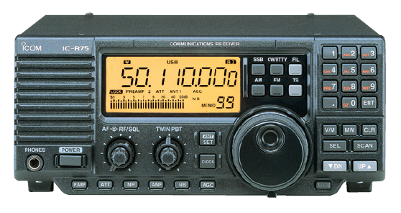

The Icom R75 receiver is a popular communications receiver that is useful for radio astronomy in the shortwave bands. Several observers are using them to detect radio noise bursts from Jupiter and the Sun in the vicinity of 20 MHz, as part of the Radio Jove program.
One feature that makes the R75 suitable is that the automatic gain control (AGC) can be turned off. By properly adjusting the preamplifier and RF and AF gain control settings we can achieve good dynamic range performance. This means that we can receive signals that are as strong as 30 dB above the noise floor without the receiver going into saturation. The noise floor itself is primarily due to galactic background radiation plus terrestrial radio noise. Very strong solar radio noise bursts can be at least1000 times (30 dB) stronger than the galactic background noise.

Making the R-75 useful for radio astronomy is therefore a two step process. First we need to set the receiver controls up for good dynamic range performance and then we need to convert the vertical scale of SkyPipe from SkyPipe Units (SPU) to antenna temperature.

Setup for Best Dynamic Range.
Let’s begin by describing how to adjust the
Before proceeding with calibration, it’s necessary to set the R75 for its maximum dynamic range. A series of tests were conducted on my personal R75 and the results are at the end of this paper. Make sure that your receiver, be it an R75 or other, has been adjusted to maximum dynamic range before continuing.

For a more detailed explanation and rational of the following, please see:
http://radiojove.gsfc.nasa.gov/observing/Measuring Antenna Temperature Jove.pdf

Calibrating SkyPipe¹ to display the equivalent antenna temperature in degrees Kelvin makes the data recorded more meaningful and comparable with other observers who have also calibrated their equipment. SkyPipe can do a single temperature calibration using the Cal Wizard and single temperature noise source within SkyPipe itself. However, some non-Radio JOVE receivers will need to do a multi-step calibration procedure and manually add calculations within SkyPipe for SkyPipe to plot temperature in degrees Kelvin. A calibration equation can be developed using the curve fitting utility in Excel and that equation is manually entered in SkyPipe. This guides you through that process. The values shown here are for explanation purposes only. Your data values will depend on your specific equipment and settings.

The Procedure:

Any noise source of known output temperature² such as an HP 461A is connected to the receiver³ through a step attenuator such as the Kay Step Attenuator, Model 30-0 – 432D (Fig 1). You need a hot noise source that can drive the receiver into saturation.
See the plot at the end of the paper where the response starts to flatten out at the highest temperatures. This means typically that you need a source capable of developing tens of millions of degrees. You can’t develop a calibration curve that goes all the way up to tens of millions of degrees if the noise source only puts out say a couple of million degrees.
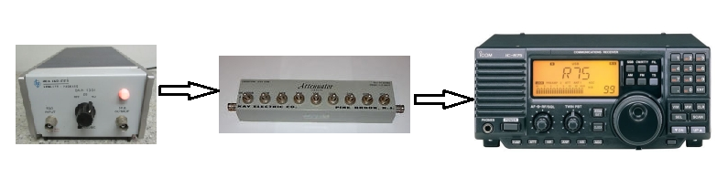
Fig 1
First, you will first create a stepped noise source file (Fig. 2) as outlined below. Start SkyPipe and beginning with a low noise level (high attenuation) inserted into the antenna input of the receiver being calibrated, increased the noise level by reducing the attenuation incrementally, keeping track of the db of attenuation for each step so that each steps temperature is known. Each noise level should be allowed to run long enough to get a good sample (30 seconds is adequate for each step). There is an alternative method to get these values⁴. Whichever method you use, you will need to write down the input temperature and displayed SkyPipe value for entry into the spreadsheet. When the final temperature is completed, stop SkyPipe which automatically saves the chart.
The resulting file from the multi-step calibration process is then loaded into SkyPipe (it should look something like Fig 2) and each temperature level is averaged using the “Get Average for View” feature in SkyPipe (or via the alternative method⁴). Simply use the zoom feature so that the area you want to measure covers the visible area of the chart. Then right click on the chart and select "Get Avg for View". The average Y value for the visible portion of the chart will appear in the status bar and entered into your spreadsheet plus the noise source temperature for that step (Table 1).
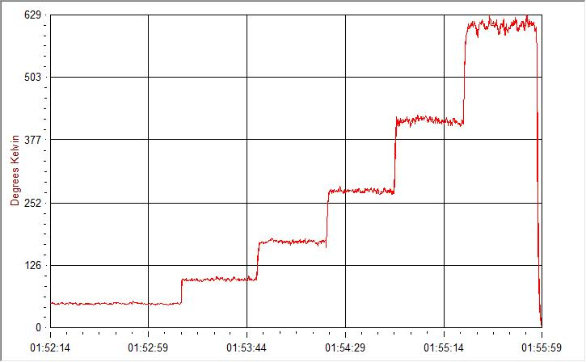
Fig 2
Example of multi temperature steps

To develop a true calibration from the hottest solar burst to a Jupiter emission,
the hottest temperature in your calibration procedure should be at least 40 Mk.

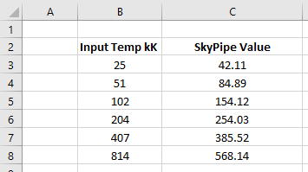

Table 1
The input noise source temperatures and SkyPipe response values are entered in the spreadsheet

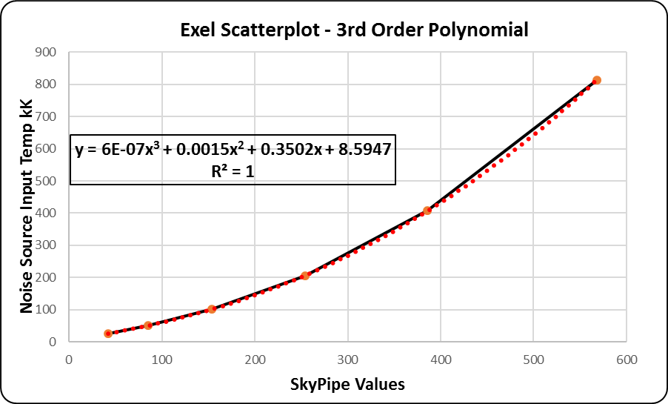

Fig 3
The values are plotted to obtain this example scatterplot graph

Use Excel’s TRENDLINE function to fit polynomials to the data. Graph your data using the scatterplot function, then using a feature called Curve Fit (Fig 3) (Excel graphing function⁵), apply a 3rd order polynomial to the data and your graph will produce the equation where X is the value for the current value in SkyPipe:

=(0.0000006*(X^3)) +(0.0015*(X^2)) +(0.3502*(X)) +8.5947

Next, open the SkyPipe formula entry section and set up the equations (Fig 4) as follows using the numbers you obtained from the 3rd order polynomial your graphed data provided.

A=X;B=X^2;C=X^3; =(0.0000006*(C^3))+(0.0015*(B^2))+(0.3502*(A))+8.5947

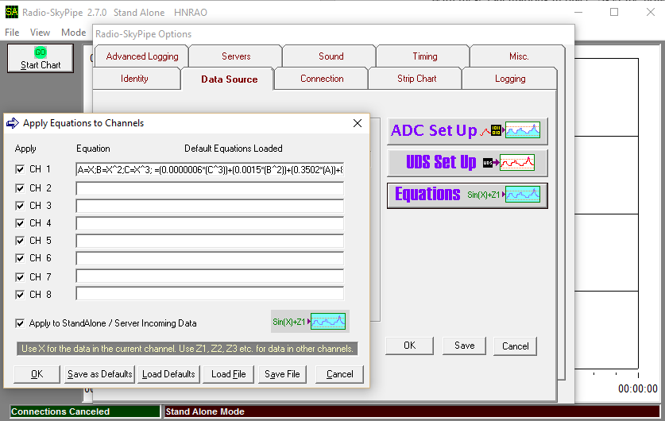

Fig 4
Equation entry is under the Data Source Tab, Equations button

Table 2 shows the example input temperatures and the values resulting from SkyPipe applying the calculations.

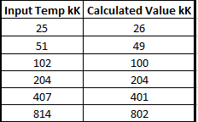

Table 2

As you can see from the chart, SkyPipe plots a temperature of 26 kK when the actual temperature is 25 kK at the receiver antenna input. SkyPipe plots a temperature of 49 kK when the actual temperature of 51 kK is presented to the antenna input of the receiver, and so on. The results are very close to the actual values and the difference is negligible.

With these calculations in place, SkyPipe now displays the output in degrees Kelvin.

Make sure “Apply Calculations” box is checked for the calculations to be used in SkyPipe when plotting (Fig 5).

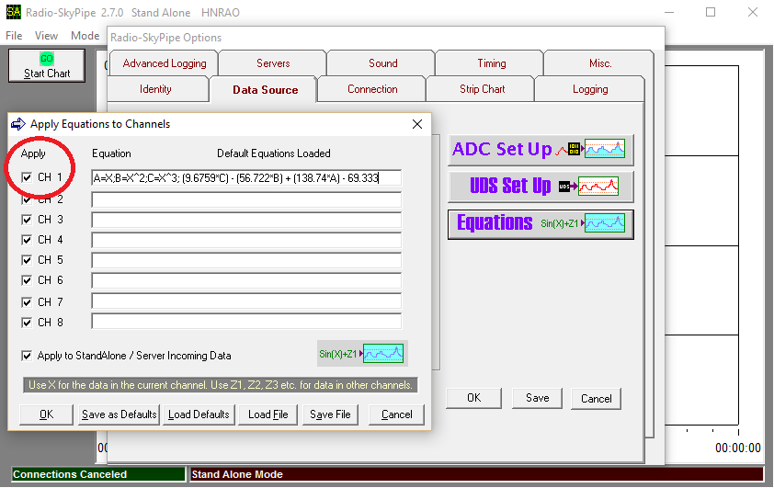

Fig 5

IMPORTANT.

Since you are using the speaker output of your receiver as the sound source for SkyPipe, ANY adjustment of the volume control at this point will void the calibration your just performed.

----------------------------------------------------------

¹ http://radiosky.com/

² The noise source must generate a temperature in the tens of millions of degrees. An excellent noise source is the HP 461A. These are readily available on eBay, for example. The noise source must also be calibrated against a known source to determine its exact output temperature in Kelvin. The temperature of each inserted attenuation of db can then be calculated to determine the temperature of each step. See table 3.

³ For a detailed explanation of dynamic range, see:
http://radiojove.gsfc.nasa.gov/observing/Measuring Antenna Temperature Jove.pdf

⁴ Or, you can find the average value for live data arriving in a chart over a period of X seconds by pressing the ALT key and a number key corresponding to the channel number you want to average. For example, pressing ALT and the "1" key will begin calculating the incoming average for channel 1. The duration in seconds for the averaging is the Key Press Averaging Period (the time you hold down the ALT and number key).

⁵ Depending on which version of Excel you use, the 3rd order polynomial function feature will have a different procedure in the graphing section. Check the help files to determine how to use it if you aren’t already familiar with it.

----------------------------------------------------------------------------------------------------

R75 dynamic range settings.

A series of measurements were taken (Figure 6) with the Icom R75 to determine the maximum dynamic range of the receiver for using it for observing Jupiter and the sun. Solar bursts can be in the millions of degrees Kelvin so it’s important that the receiver not go into saturation. Saturation meaning the point at which the receiver can’t process anymore signal and on a chart, is displayed as a flattening out. You can see this on the graph below where the signal begins to flatten out at the top right. The further up the Y axis you can push this flattening out at the maximum signal, and the closer to the bottom of the Y axis with the lowest signal means the more the receiver is linear. Meaning the displayed temperature in SkyPipe is consistent from lowest to strongest signal at the antenna port.

The settings that proved to provide the maximum dynamic range consisted of:

- Audio taken from speaker jack.
  - The line level jack simply does not provide sufficient output audio.
    - The downside of this is you can’t monitor the receiver audio.
- The AF Gain (volume control) set to the 10 o’clock position.
- The RF gain setting at 4.5.

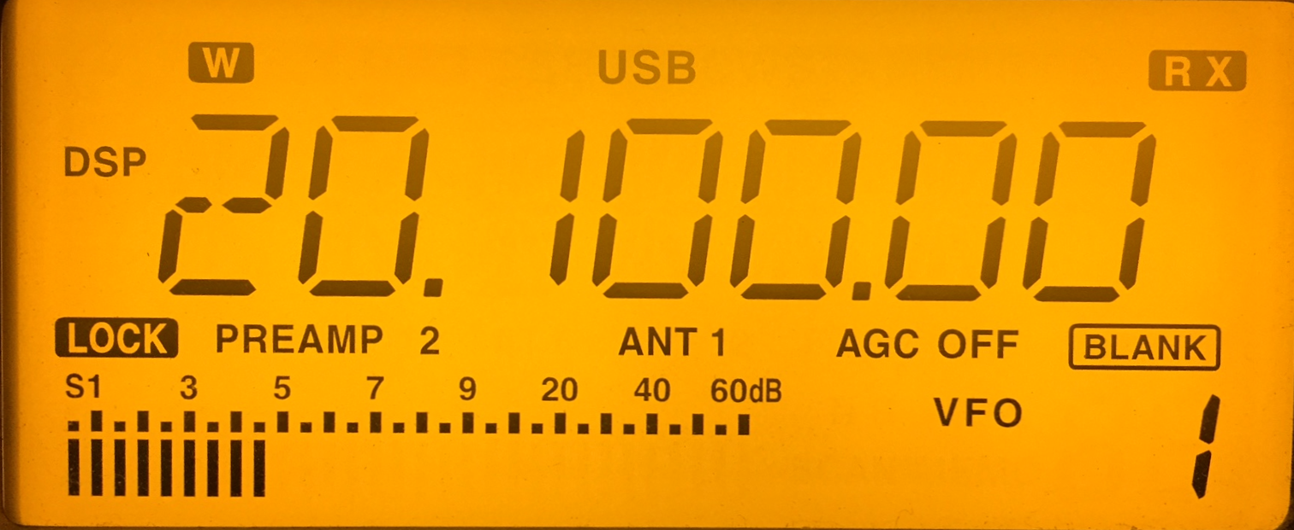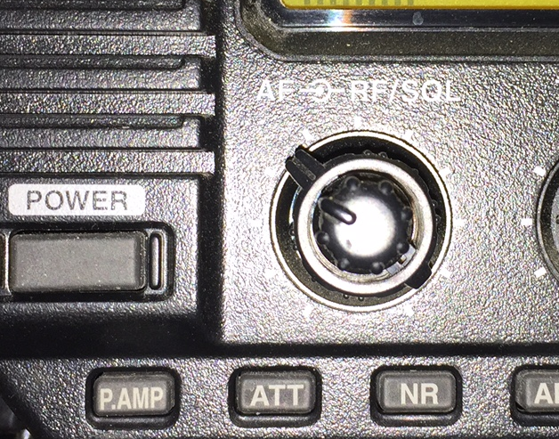

Your settings may vary slightly, but this is a good starting point. If you are using a receiver other than the R75, you will need to experiment until you’ve established the range. An example of what the Excel spreadsheet for collecting the information to produce the graph is below.

Figure 6

Millivolts are read from a voltmeter connected to the speaker output on the rear of the R75.

The relative power formula is =(L2^2)/L2

Table 3

