TWB Observation Target Dec 25, 2014 – Wednesday night / Thursday morning
Beam Steering 15° S, 0° EW On Duty: 0730UTC / 0230 LOCAL

Phase plane at transit 0855 UTC
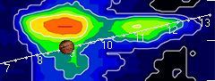

TFD Array 20 MHz HPBW 15° NS x 35° EW
