TWB Observation Target Dec 19, 2014 – Thursday night / Friday morning
Beam Steering 15° S, 30° W On Duty: 0900UTC / 0400 LOCAL

Phase plane at transit 0920 UTC
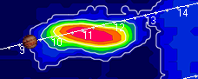

TFD Array 20 MHz HPBW 15° NS x 35° EW
