Screen shot taken in real time from the DPS machine, 4/26/13:

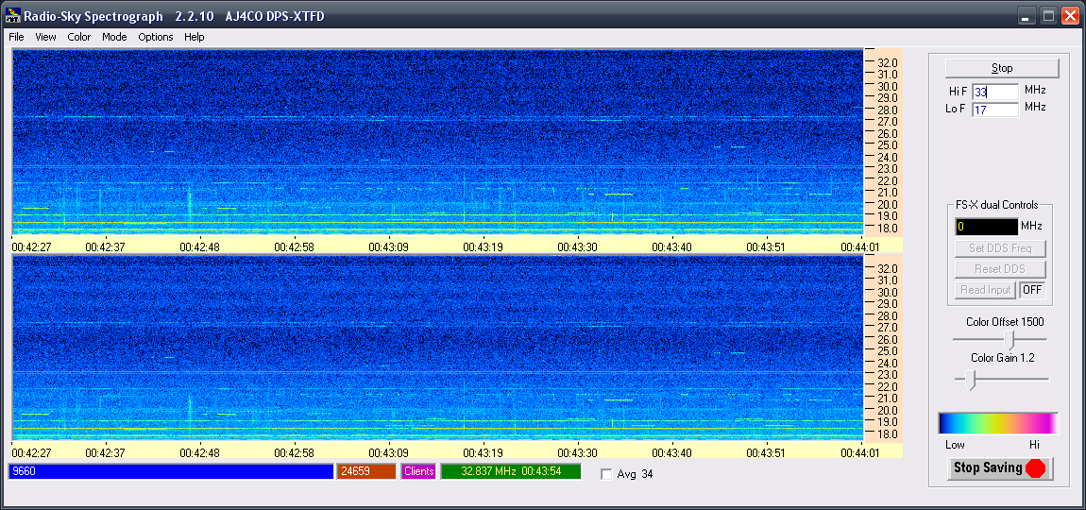

Screen shot taken in review mode of 4/26/13 data file from home workstation, 4/29/13:
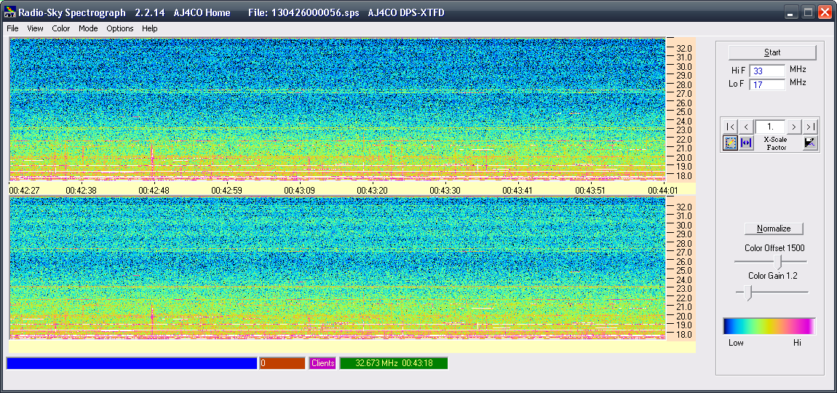

Screen shot taken in review mode of 4/26/13 data file from home workstation, 4/29/13: (BUT – first hit “start” to try to start the non-existend DPS hardware,. then selected Mode -> Stand Alone to unlock the app from trying to find the DPS hardware, then loaded the data file.)
